### How to Link Stakeholder Records in PENFAX

When the warning message of, *“Member does not exist in system*” or “*Last name and birthdate match an existing record in the database”* is received in a contribution file or enrolment file, the user must investigate PENFAX to determine if the person does or does not exist as a Stakeholder in PENFAX. The user must ensure if a Stakeholder record is found that the person is the same as the one the contribution is for.

PENFAXuses a **SIN** number to link an Enrolment or data posting to an existing stakeholder account. Thus, this creates a few scenarios where you need to do the same thing, but in a *different* way:

1. SIN number on PENFAX, but not in the Enrolment file
2. SIN number **not** on PENFAX, but is in the Enrolment file
3. SIN number **not** on PENFAX and **not** in the Enrolment file
4. SIN number **not** on PENFAX and **not** in the Enrolment file and the stakeholder account on PENFAX is **not** a member of PEPP

Following are the steps for each of the above scenarios (note, for time sake only screenshots for the first scenario are provided which should assist you in all scenarios how to navigate within PENFAX to investigate.

*Scenario 1*: *SIN number on PENFAX, but not in the Enrolment file*

* 1. This validation WARNING will appear in Data Postings on PENFAX (**Note:** this will be after the enrolment file comes in from DCT/Employer PLANet). When this warning is received you MUST investigate to figure out if the stakeholder on PENFAX is *truly* the same person.

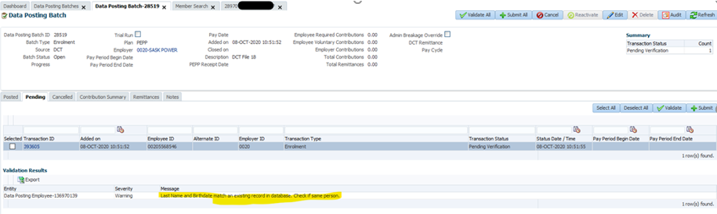

* 1. Open the specific Transaction by clicking on the “**Transaction ID**”.

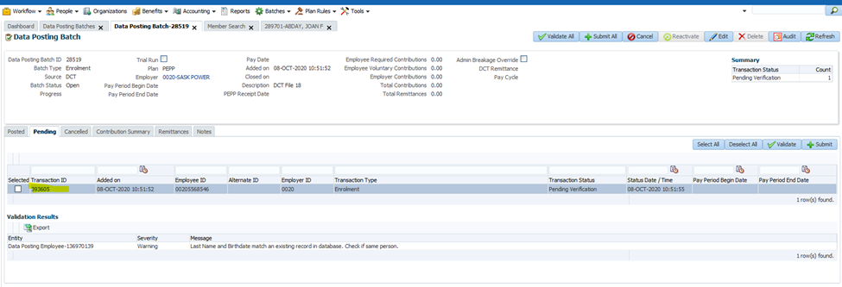

* 1. Once this opens up, verify if the Enrolment has a SIN or not by opening the “**Personal Data**” tab and looking under the “**Identification**” section. For this specific Enrolment there is no SIN in the file.

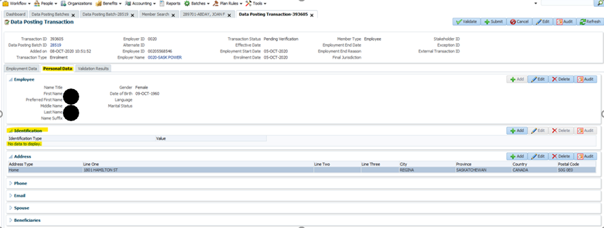

* 1. Go to **Person Search** or **Member search** (person search will be more reliable) to find the stakeholder.
  2. Once you have found the stakeholder open the stakeholder’s account and go to their **Person Profile** to check if they have a SIN on file. **Note:** locate the SIN by expanding the “**Identity**” section and looking under the “**Identification**” area.

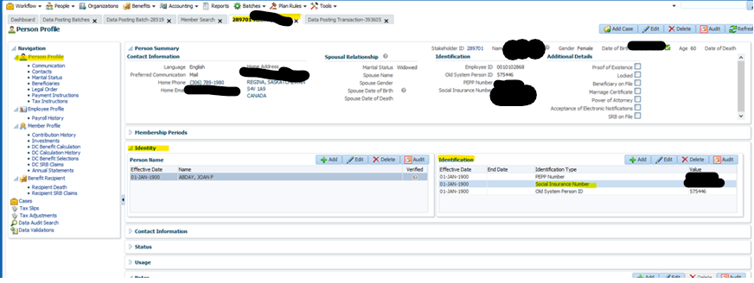

* 1. If a SIN is found go back to the Data Posting Transaction, **Personal Data** tab and add the SIN (i.e. the Enrolment). Click **Save** once entered.

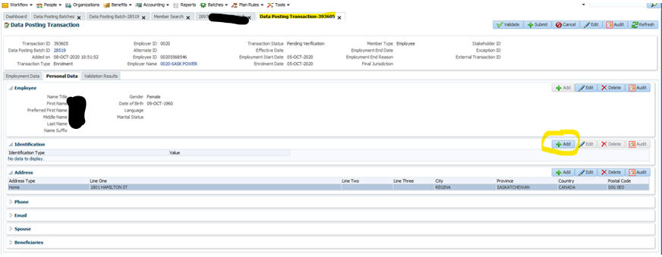

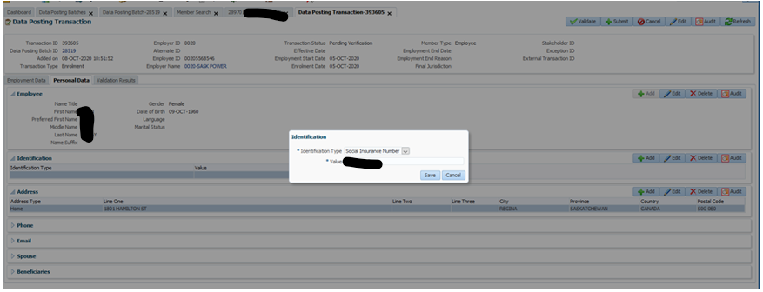

* 1. Go back to the Data Posting batch, select the transaction and click **Validate**. If the address is different on the Enrolment compared to the account on PENFAX, you will get a second warning to inform you. If it is okay and if you are sure it is still the same person, select the transaction and **Validate** it again to change the status to “**Valid**”.

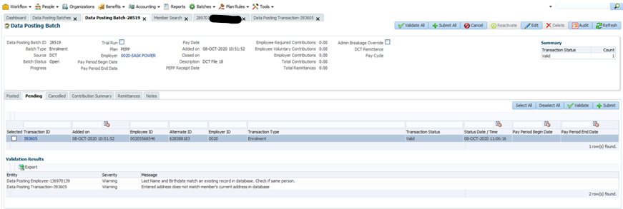

* 1. **Submit** the file and it will add the new employment period to the stakeholder account already on PENFAX.

*Scenario 2: SIN number* ***not*** *on PENFAX, but is in the Enrolment file*

1. The steps are exactly the same as scenario 1, but you will need to copy the SIN from the Enrolment and add it to the stakeholder account located on PENFAX.

*Scenario 3: SIN number* ***not*** *on PENFAX and* ***not*** *in the Enrolment file*

1. The steps are exactly the same as scenario 1, but you will need to create a fake SIN number by taking the PEPP Member Number and adding 18 to the end of it.

1. Add the fake SIN to the stakeholder account in PENFAX (under the “**Identity**” section) and under the Enrolment file (see step F from scenario 1).

*Scenario 4: SIN number* ***not*** *on PENFAX and* ***not*** *in the Enrolment file and the stakeholder account on PENFAX is* ***not*** *a member of PEPP*

1. The steps are exactly the same as scenario 1, but you will need to create a fake SIN number by taking the PEPP Member Number and adding 18 to the end of it.

1. In this scenario the member does not have a PEPP Member Number. So, you need to create it. (**Note: this member does have a SIN, but it would take too long to find a MEPP member without one to use)**.

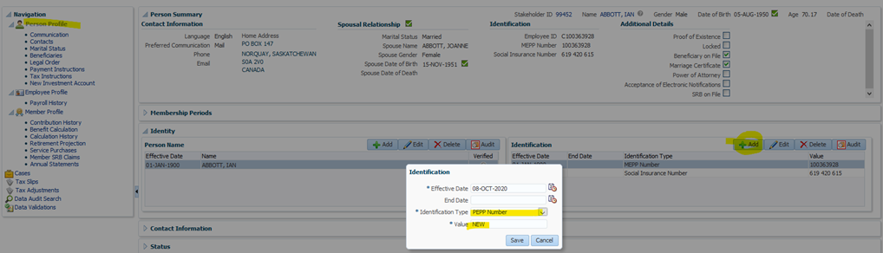

1. After you click save, you will see the PEPP Member Number to use.

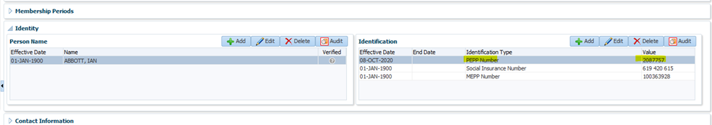

1. Add the fake SIN to the stakeholder account in PENFAX (under the “**Identity**” section) and under the Enrolment file (see step F from scenario 1).
2. If the member does exist as a Stakeholder such as a beneficiary to a member but they are not a member of a plan, you must link the contribution data to the existing Stakeholder record.
3. The **Posted, Pending** and **Cancelled** tabs all display the **Transaction ID** for each separate transaction. Clicking the **Transaction ID** opens the transaction details on the **Data Posting Transaction** screen in the selected new tab.

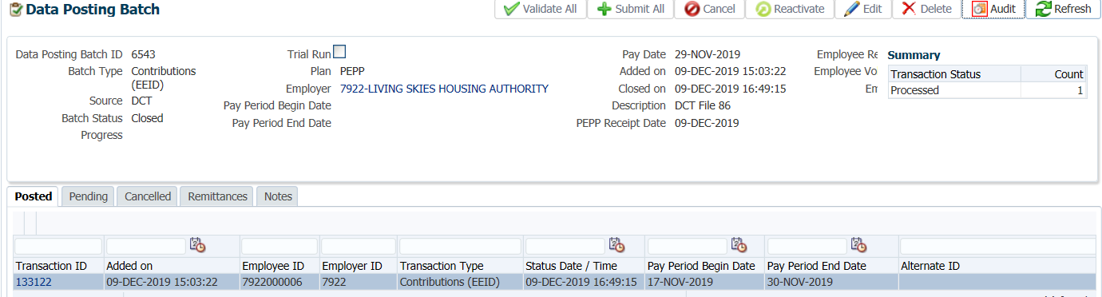

1. The **Data Posting Transaction Screen** displays information about the selected transaction and can be used to update information to correct any errors or add any missing information only if the batch status is **Open**.

Only the fields relevant to the current transaction are populated. The **Validation Results** tab displays errors and warnings encountered for the transaction during each validation process.

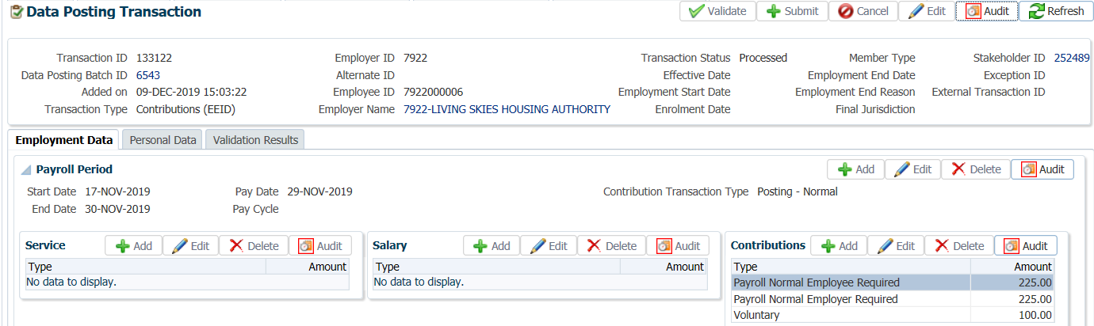

1. To view the payroll contributions under the member’s account, go to the **Investments** screen under the Navigation menu, Member Profile menu. Under **Account Activity** click on **Search** to bring up all financial transactions.

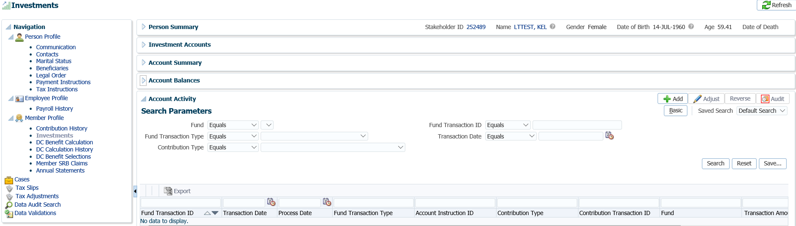

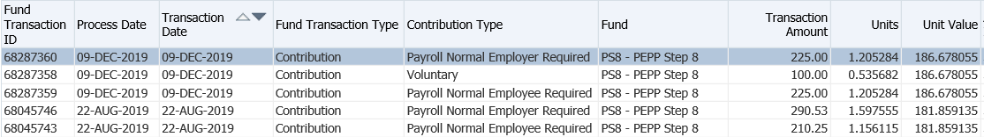

1. To see a specific type of transaction, a search can be performed in the **Search Parameters** region. Select your search criteria from the dropdown list and click **Search**.

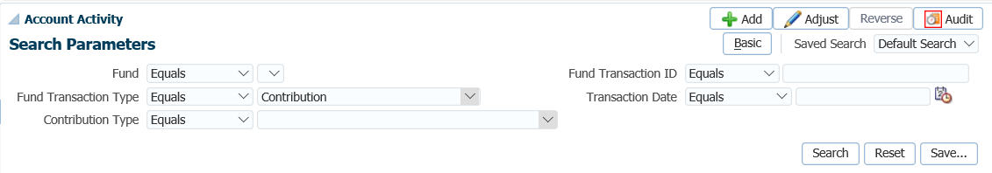

* **IMPORTANT:** If the contribution file is for the MLA, Employer #5000 see MLA procedures on how to proceed once the posting of the employee required contributions has been completed.